Name:
Institution facility:
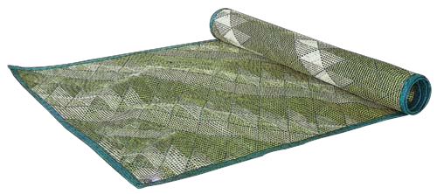

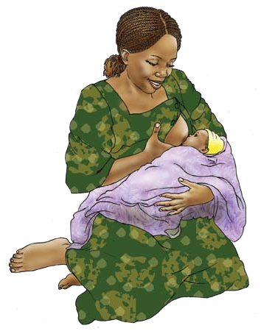
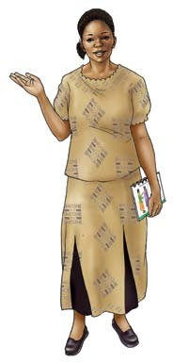
Breastfeeding

How to avoid common breastfeeding difficulties
- Position / hold the baby correctly under the breast: Remember breastfeeding ought not to hurt.
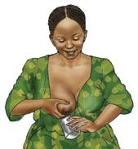
- If you have split areolas, apply some breast milk. Avoid using creams on the nipples unless recommended by a medical specialist
- Feed your baby regularly to avoid accumulation of breast milk, which will cause the breasts to swear.
- If the infant misses to feed, you can express the milk which leaves the breasts soft
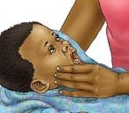
- Keep the expressed breast milk in a cool place, although not for more than 6 to 8 hours.
- If either of your bosoms end up excruciating or hot to the touch, see a medical guide.
- Check for injuries and thrush in your child's mouth. On the off chance that you discover any, consult from a medical specialist
- Mixed bolstering (mixing the breast milk with whatever else) isn't sound for your infant before a half year of age. Mixed feeding lessens the measure of drain that you create and can influence your child to debilitated.

Things to recall
- Exclusive breastfeeding amid the initial a half year shields you from getting pregnant as long as your periods have not resumed. Seek advice from a family planning guide as quickly as time permits in the wake of conceiving an offspring.
- When your child is a half year old, keep breastfeeding and start giving different nourishments.
- Watch for indications of diarrhea, fever, trouble in breathing, or refusal to feed which calls for medical attention
- If the mother is HIV +, she ought not nourish her infant from an areola that is split. Rather, sustain from the other bosom and express and dispose milk from the bosom that is affected.




- Getting infected or re-infected with HIV while breastfeeding risks mother to child HIV transmission. Practice safe sex by using condoms consistently and correctly.
- To protect your baby, it’s crucial know your HIV status.

How to
Breastfeed the
Baby

Breastfeeding

What t o k n o w?

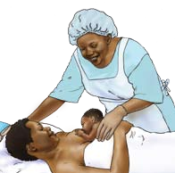
Help the infant connect to your breast

How often do you need to breastfeed?

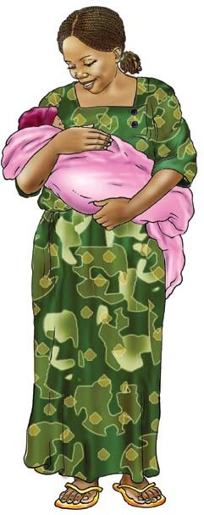
- Breast milk gives all the sustenance and water that your child needs amid the first half year of life.
- Make beyond any doubt you nourish your infant the primary yellowish drain known as colostrum.
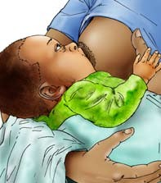
- Colostrum shields your child from numerous sicknesses.
- Exclusive breastfeeding implies giving breast milk just, and that's it (no other different milks, sustenance’s or fluids, or water), unless any other prescriptions recommended by a medical specialist
- Feeding your infant both with breast milk and different nourishments or fluids, including newborn child recipe, creature milks, or water ('blended bolstering') before a half year lessens the measure of breast milk that you deliver and can influence your child’s sickness
- Put the child to your bosom within the principal hour of birth.
- Good connection guarantees that your child suckles well.
- Good connection encourages you to create a decent supply of breast milk.
- Good connection forestalls sore and split areolas.
- It is crucial to attach to your baby well when breastfeeding :
Touch infant's lips with your areola
• Wait until the point that your infant's mouth opens wide
• Quickly bring onto your bosom from beneath, pointing your areola up towards the top of the child's mouth
• Baby should take a major sizable chunk of bosom
- The four symbols of good connection are:
- Baby's mouth is completely open
2. You can see a greater amount of the darker skin (areola) over the infant's mouth than underneath
3. Baby's lower lip is turned outwards
4. Baby's jaw is touching your bosom

- Your child should take moderate profound sucks while breastfeeding, now and again delaying
- Breastfeed your infant on request, both day and night, no less than 8 to 12 times every day.
- Frequent nourishing will enable your body to create bosom to drain.
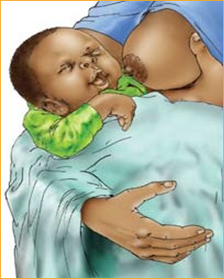
- Continue to bolster until the point that your child completes the bosom and falls off alone. Offer the other bosom and let your child choose in the event that he or she needs more or not.

You will know whether your infant is sufficiently taking bosom drain on the off chance that he or she passes light-shaded pee no less than 6 times each day and is putting on weight.

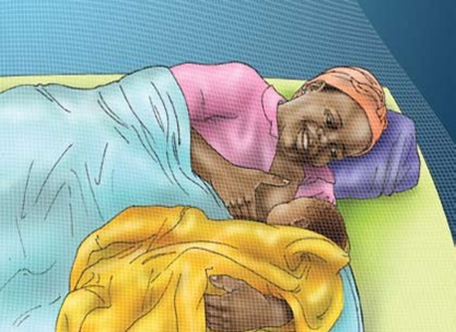

References

Cadwell, K. (2016). Maternal and infant assessment for breastfeeding and human lactation: A guide for the practitioner. Sudbury, Mass: Jones and Bartlett Publishers.
In Genna, C. W. (2017). Supporting sucking skills in breastfeeding infants.
Lawrence, R. A. (2016). Breastfeeding: A guide for the medical professional. Philadelphia, Pa: Saunders.
Odent, M. (2017). Birth and breastfeeding: Rediscovering the needs of women during pregnancy and childbirth. Place of publication not identified: Clairview Books.
Riordan, J. (2014). Breastfeeding and human lactation. Sudbury, MA: Jones and Bartlett.
World Health Organization., & UNICEF. (2013). Global strategy for infant and young child feeding. Geneva: World Health Organization.

